python(inspection)
Virtuval Inspection

Simple Graph Documentation Using Iris Dataset
This document explains graphs in very simple words using the Iris dataset. Each graph includes: explanation, why we use it, and Python code.

About the Iris Dataset
The Iris dataset has information about 3 flower species:
- Setosa
- Versicolor
- Virginica
Features:
- Sepal Length
- Sepal Width
- Petal Length
- Petal Width
We use this dataset to learn graph visualization.

1. Bar Plot
What it shows:
Count of each category.
Why we use it:
To see how many samples each species has.
import seaborn as sns
import matplotlib.pyplot as plt
from seaborn import load_dataset

df = load_dataset('iris')

sns.countplot(x='species', data=df)
plt.title("Bar Plot - Species Count")
plt.show()

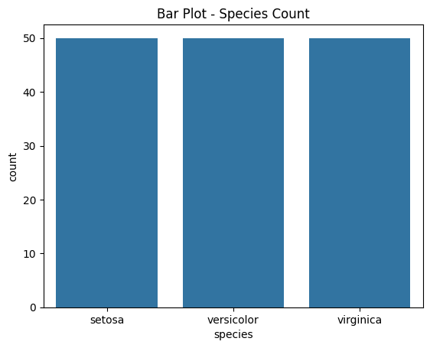

2. Line Graph
What it shows:
Values changing over time or sequence.
Why we use it:
To see how sepal length changes from sample to sample.
plt.plot(df.index, df['sepal_length'])
plt.title("Line Graph - Sepal Length Trend")
plt.xlabel("Index")
plt.ylabel("Sepal Length")
plt.show()

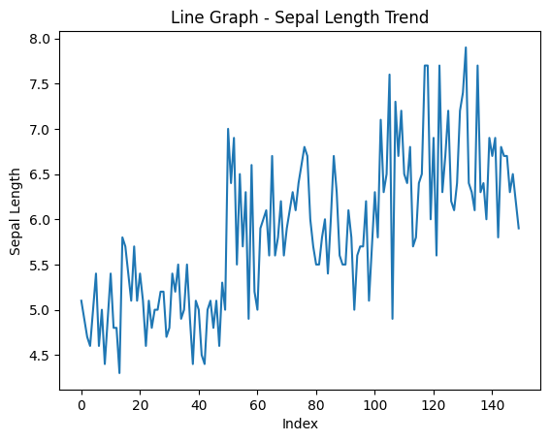

3. Pie Chart
What it shows:
Percentage of each category.
Why we use it:
To see how much percentage each species takes.
sizes = df['species'].value_counts()
labels = sizes.index

plt.pie(sizes, labels=labels, autopct='%1.1f%%')
plt.title("Pie Chart - Species Percentage")
plt.show()

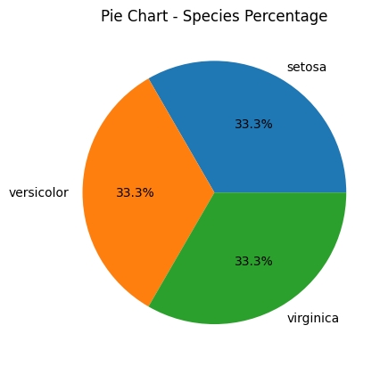

4. Histogram
What it shows:
How values are spread.
Why we use it:
To see distribution of sepal length.
plt.hist(df['sepal_length'], bins=10)
plt.title("Histogram - Sepal Length Distribution")
plt.xlabel("Sepal Length")
plt.ylabel("Frequency")
plt.show()

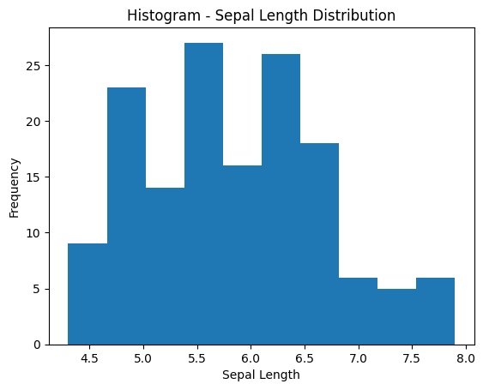

5. Scatter Plot
What it shows:
Relationship between two values.
Why we use it:
To compare sepal length and sepal width.
sns.scatterplot(x='sepal_length', y='sepal_width', data=df, hue='species')
plt.title("Scatter Plot - Sepal Length vs Width")
plt.show()

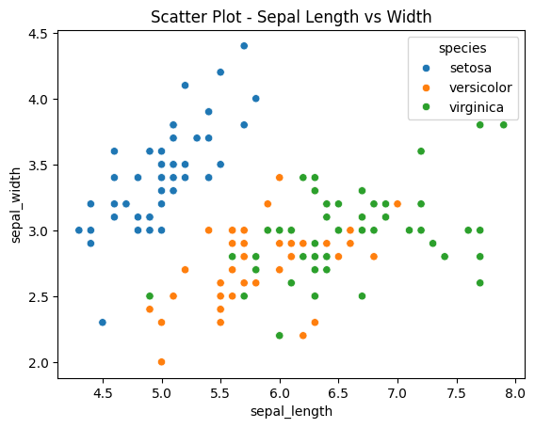

6. Box Plot
What it shows:
Median, spread, and outliers.
Why we use it:
To compare sepal length across species.
sns.boxplot(x='species', y='sepal_length', data=df)
plt.title("Box Plot - Sepal Length by Species")
plt.show()

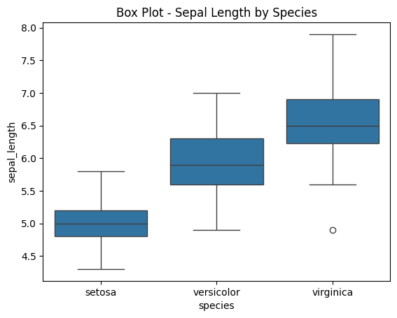

7. Violin Plot
What it shows:
Shape and spread of data.
Why we use it:
To see distribution of petal length.
sns.violinplot(x='species', y='petal_length', data=df)
plt.title("Violin Plot - Petal Length by Species")
plt.show()

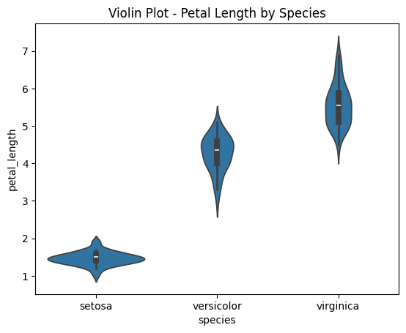

8. Donut Chart
What it shows:
Pie chart with a hole.
Why we use it:
To show proportions in a clean way.
sizes = df['species'].value_counts()
labels = sizes.index

plt.pie(sizes, labels=labels, wedgeprops={'width':0.4}, autopct='%1.1f%%')
plt.title("Donut Chart - Species Share")
plt.show()
